Scientific Note for Publication in the
Proceedings of the Florida State Horticultural Society

The idea of a scientific note is that the author(s) found something of interest and will publish a longer refereed paper on this topic at a later date. In the case of an Extension author, this could be for a program that may be of interest to a wider audience. In all cases, the author must be able to write a concise description.

Components:

Title
Author(s)
Affiliation(s) (main workplace[s], city, state) [e.g., Indian River Research and Education Center, University of Florida, IFAS, Ft. Pierce, FL]
Keywords (formerly Additional Index Words) – include 3-4 keywords
Objectives
Findings
Suggestions for future direction
Literature Cited is recommended, but not mandatory unless a paper(s) is/are cited. If you opt to use references, please use the new FSHS formatting.

Page limit: 1 published page, with the editor having the ability to cut it off when she/he reaches the word limit or the author can edit to the recommended page length beforehand. The recommended total word count is around 700 words (use: file>properties>statistics). There may be a substantial additional page charge for second and subsequent published pages.

Authors may add brief tables, illustrations, etc., but should reduce the number of words to accommodate these additions.

Précis vs. Abstract: Rather than submitting a complete abstract during the call for titles and abstracts, the author may submit a very short description (précis) of the information that will be presented.

Do not use line numbering or page numbers. Do not use right justification. Please use Times New Roman 12 pt throughout with 1.5 or 2 as the line spacing and 1” margins.

Please look at the example from the 2021 meeting on the next page. It has a total of 615 words, including: Proc. Fla. State Hort. Soc. 134:131. 2021. and –Scientific Note–
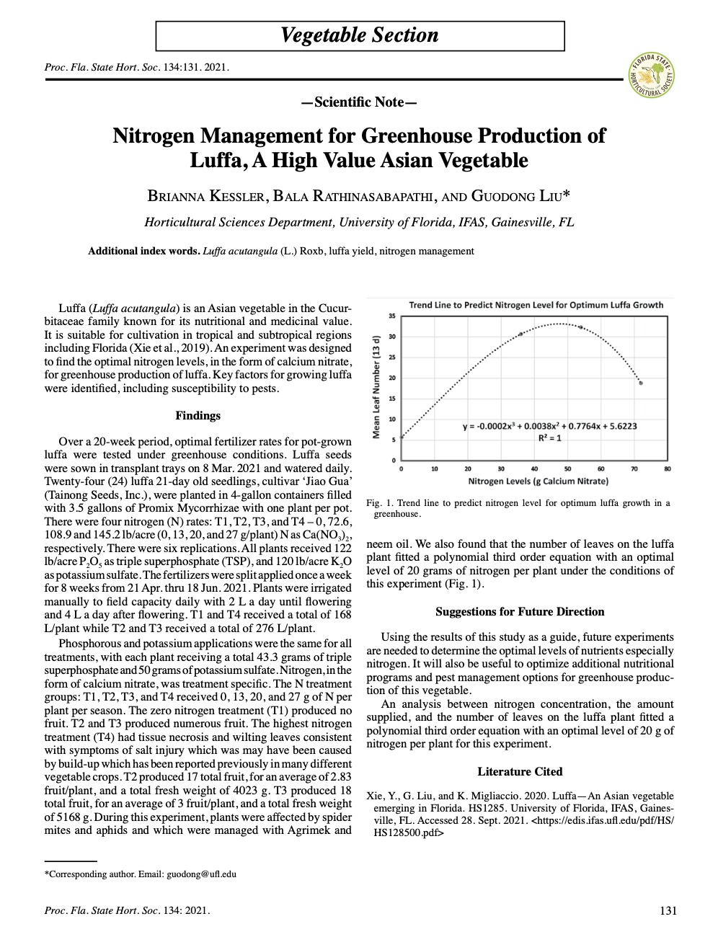

A published page has more words than a printed page, even if the printed page is single spaced with very narrow margins. In 12 pt Times New Roman double spaced throughout with 1” margins, 3 pages should equal 750 words. You can use this as a guide and make the Scientific Note 50 words shorter than that.

